***SMB-A Capstone Project Report – BUSML 7249***

***WOSU Donor Database Analysis and Segmentation***

***by Shyni David***

**Introduction**

WOSU’s primary source of funding comes from individual community support. With over 27,000 donors providing annual support equaling approximately $4 million with additional major and planned gift support, the development team seeks to develop a deeper understanding of our constituency.

Currently, the development teams work out of multiple databases and static documents with a treasure trove of disparate data about their donors. From analytics needs assessment, WOSU is at the base level of analytics and need to lay the foundation in order to further utilize our data for targeted fundraising approaches, but also to eventually build toward predictive modelling of future WOSU donors.

**Objective**

WOSU’s primary source of funding comes from individual community support. Their development team is seeking to develop a deeper understanding of the constituencies by using data analytics in understanding the past and projecting the future. When donors approach philanthropy, their gifts are thoughtful and has intended purposes and seek a return on their philanthropic investments.

WOSU has a wide variety of fundraising programs through events, radio, TV, web, emails and personal contact. Which of these tasks contribute to increased giving? Which tasks detract from the fundraising success? What is the spread of the donors across the country? What should the campaign goal be? What are the factors for their success?

The exploratory data analysis will be used to investigate the trends. The statistical tools and techniques will help to interpret the data and build models to increase the predictability, thus empowering WOSU to strategically invest their resources in increasing the scalability and sustainability of donations.

**Data**

There are 3 Datasets provided by WOSU:

1. 2000-2009 – 33740 observations (represents First time Donations), 22 variables/attributes
2. 2010-2018- 36361 observations (represents First time Donations), 22variables/attributes
3. Event files – 22 Text files corresponding to some events 2014-2018 with the names and date and other related information.

**Data Analysis**

Selected Variables

1. EnvSalu - Donor Name - Char
2. LetterSalu- Letter Salutation - Char
3. City - Char
4. StateProv - State - Char
5. AcctSts - Account Status - Char
6. OrigGiftDate - Original Gift Month Year - Date
7. OrigGiftAmt - Original Gift Amount - Numeric
8. OrigGiftSrc - Original Gift Source - Char
9. OrigGiftMode - Original Gift Mode – Char
10. SolType - Original Gift Solicitation Type - Char
11. SolMeth - Original Gift Solicitation Method -Char
12. OrigGiftHasPremFlag - Original Gift Has Premium – Char

The following variables are not needed for my analysis.

1. PBS Digital Token
2. Passport Activation Date

Redundant Variables:

1. AcctID - Account ID - Char
2. Zip Code+4 digits
3. SeqName -Sequence Name
4. Addr1 - Address Line1
5. Addr - Address Line 2
6. EmailAddr - Email address
7. OrigGiftPlgType - Original Gift Pledge Type
8. OrigGivingLevelAmt - Original Gift Level Amount
9. **Attribute Information:**

* Donor Name (qualitative)

Name of the donor as a first name and Last name.

* Letter Salutation (qualitative)

Salutation to individual donors with prefix as Mr. or Mrs. and Organization names.

* City(qualitative)

The data spans around many states in US and territories.

* State (qualitative)

* Account Status (qualitative)

The statuses are expired, contributor and active.

For example, if the first gift was on April 2, 2004, it will be in the Original Gift 2000-2009 file.  People/organizations who stop giving are considered as expired.  People/organizations who are still donating are considered as active/contributor. These files are based on original giving date.

Per Rob Walker, Active member give $60, Contributor gives $59 or less, Expired status refers that the individual or organization is no longer a member.

* Original Gift Month Year (numerical )

The Original giving date for the donor.

* Original Gift Amount(numerical)

The Original donation amount or the donations received for the first time.

* Original Gift Source (qualitative)

Has the detailed information of the event that initiated the donation. Per Rob Walker, TOOP is an internal phrase for a one-off TV pledge drive and can be categorized with TV drives. LAPS is a Lapsed member who has not given in the past 12 months before that gift. Some of the Solicitation descriptions in Original Gift Source can be replaced with the descriptions in the variable Original Gift Solicitation Method.

* Original Gift Mode(qualitative)

This field describes how the payment has been made like by CC, Cheque, Cash or EFT.

* Original Gift Solicitation Type(qualitative)

Generalized description of Solicitation type specially to identify Additional Gifts.

* Solicitation Method (qualitative)
* Original Gift Has Premium (qualitative)

This mean that when the donor made their first gift, they ask for a thank you gift.

Redundant Variables :

* Account ID (qualitative) - This is a unique ID that is randomly assigned when donors make their first donation. These are the people who made their first ever gift in those years.
* Original Gift Level Amount(numerical) -This is the amount of their first gift ever. Is a redundant field.
* Original Gift Pledge Type(qualitative) - This field is same as Solicitation Type
* Sequence Name(qualitative) – This field is same as Donor name.
* Addr1(qualitative) - Address Line1
* Addr(qualitative) - Address Line 2
* Zip code (qualitative)

Zip code + 4 digits(qualitative) - Zip codes were devised entirely for the USPS mailing efficiency. They do not necessarily end at the county line, city line or any political boundary except the national border. The State and the City variables are more informative of the geographical location.

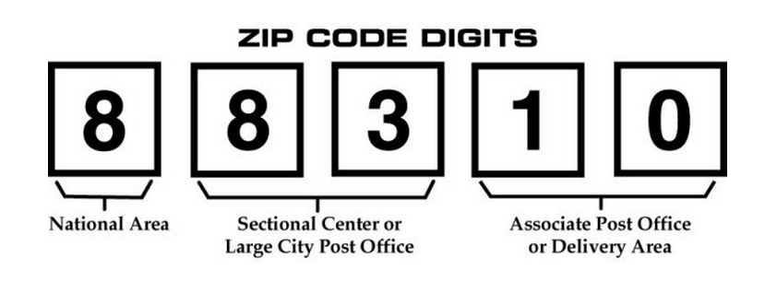

1. **Data Wrangling**

The Exploratory Data Analysis will be segmented for Individuals and organization for in state(OH) and out of state(all other US states).

The Original Gift Data file has to be wrangled for the following:

* + 1. Split Year, Month, Day
    2. Eliminate redundant variables
    3. Lower case for all char fields
    4. Solicitation source mutate to another root word field as a categorical variable.
    5. Split Donor name as first name and last name to link Event file and Original Gift Source.
    6. Mutate the Letter Salutation to create Gender field. Use gender R package.
    7. Identify Organizations with key words as company, group, corporation, foundation, organization, campaign , firm, establishment, agency, office, enterprise, operation, institution, venture, undertaking, practice, society, league, club, network etc. And keep the set of observations as a separate file.
    8. The State variable has data that spans across many states in US and territories . Ohio is the exceptional contributor so will consider separately for analysis from the rest of states. Will add additional field of Regions and Divisions as a categorical variable.

Additional Information:

Regional divisions used by the United States Census Bureau:

• Region 1: Northeast

• Division 1: New England (Connecticut, Maine, Massachusetts, New Hampshire, Rhode Island, and Vermont)

• Division 2: Mid-Atlantic (New Jersey, New York, and Pennsylvania)

• Region 2: Midwest (Prior to June 1984, the Midwest Region was designated as the North Central Region.)[6]

• Division 3: East North Central (Illinois, Indiana, Michigan, Ohio, and Wisconsin)

• Division 4: West North Central (Iowa, Kansas, Minnesota, Missouri, Nebraska, North Dakota, and South Dakota)

• Region 3: South

• Division 5: South Atlantic (Delaware, Florida, Georgia, Maryland, North Carolina, South Carolina, Virginia, District of Columbia, and West Virginia)

• Division 6: East South Central (Alabama, Kentucky, Mississippi, and Tennessee)

• Division 7: West South Central (Arkansas, Louisiana, Oklahoma, and Texas)

• Region 4: West

• Division 8: Mountain (Arizona, Colorado, Idaho, Montana, Nevada, New Mexico, Utah, and Wyoming)

• Division 9: Pacific (Alaska, California, Hawaii, Oregon, and Washington)

* + 1. The Original Gift source is a huge vital list that has to be transformed to root words for analysis. For modelling this field can be split as dummy variables.
    2. The 22 Event text file has to be combined into one file with variables as First Name, Last name, Event month, Event year, Event day , Event name and Original Gift Source(root word).

Event files : The files have no standard format .

The Invitees are recorded by name, email id, address and other logistics. Email ids can change over time but are unique and are not consistent. First and last names can be same as or different than from a first-time giver.

To be consistent with the given event file, I used names and email ids to trace back first time donors with Account ID’s.

* + 1. Check for Null Values
    2. Merge the value “Additional Gift” from variable Orig_Gift_Pledge_type into variable Solicitaion_type.

**Results of Data Pre processing**

The list of observations was mainly segmented as Donations from

* Individuals

-From Ohio USA

-Outside Ohio in USA

* Organizations
* Outside US mainland

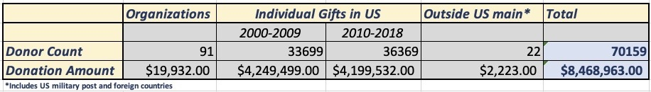

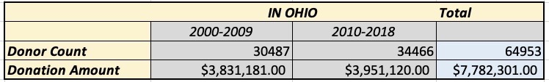

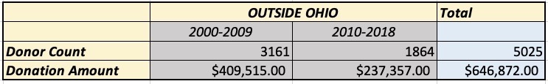

|  |  |  |  |  |
| --- | --- | --- | --- | --- |
| **As given by WOSU** |  |  | |  |
| Gifts from 2000-2009 | 33740 |  | |  |
| Gifts from 2010-2018 | 36361 |  | |  |
|  | 70101 |  |  | |  |
| In ALL |  |  |  | |  |
| Organizations | GOrg_root_03 | 91 | $ 19,932.00 | |  |
| Outside US | Gout_US_02 | 22 | $ 2,223.00 | |  |
| Gifts from 2000-2009 | Gift_00_09_05 | 33699 | $ 4,249,499.00 | | *removed records for year less than 2000 |
| Gifts from 2010-2018 | Gift_10_18_05 | 36369 | $ 4,199,532.00 | |  |
|  | Total | 70090 | $ 8,449,031.00 | |  |
|  |  |  |  | |  |
| In Ohio |  |  |  | |  |
| 2000-2009 | Gift_OH_09 | 30487 | $ 3,831,181.00 | |  |
| 2010-2018 | Gift_OH_18 | 34466 | $ 3,951,120.00 | |  |
|  | Total |  | $ 7,782,301.00 | |  |
|  |  |  |  | |  |
|  | Outside OH |  |  | |  |
| 2000-2009 | Gift_00_09_08 | 3161 | $ 409,515.00 | |  |
| 2010-2018 | Gift_10_18_08 | 1864 | $ 237,357.50 | |  |
|  | Total |  | $ 646,872.50 | |  |



**Explanatory Data Analysis**



**Figure 1**

The Events as in Figure 1 are hosted and advertised by WOSU and somehow relate back to their programming.

Here is the summarized output of Event attendees from 2014-2018

Top left highlights more attendance of women and top right it turns out that more of non-donors are event attendees.

Bottom charts show the variation of event attendees over the years and months.

From 2014 onwards, we see a steady increase in the number of attendees and beginning months of the year seems to be most preferred to attend an event and Year end, the least.

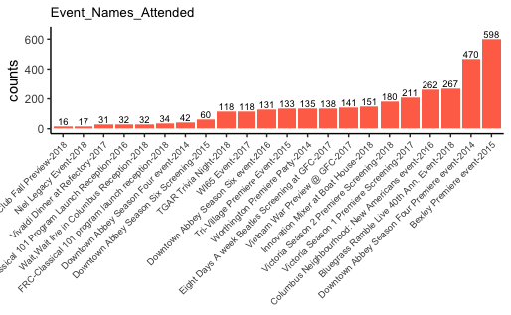

**Figure 2**

The graph in Figure 2 shows various event names and the Year and the count of people who had attended.



**Figure 3**

The top left graph of Figure 3 shows the variation of the count of donors as in the state of Ohio, outside Ohio, Organizations and Outside US( which include remote US military post overseas, US territories and foreign countries.)

The bottom right chart shows the variation of the number of donors Ohio and the rest of states in US. We see that majority of the donors are concentrated in Ohio.



**Figure 4**

The three graphs in Figure 4 shows a glimpse of the number of donors from various cities in Ohio for a cut off of 100 donors. The number of donors from Columbus Ohio is exceptionally high as 22255.



**Figure 5**

In Figure 5, we see the spread of donors outside of Ohio in US main continent.

The heat map has the color shading from blue with no donors to red in Florida which is the maximum number of donors.

The lighter shades show the scattered donors in eastern, western and southern regions.

The chart shows the cities and the state, the highest being from Chicago IL followed by Huntington WV and Moreland and Ashland in KY.



**Figure 6**

I used the term as “Outside US “ and the donations were not significant though notable from

* Remote overseas US military post offices as APO, AEO.
* US territories like Virgin Islands and Guam.
* Neighboring countries Canada and UK.



**Figure 7**

In Figure 7, we see an expanse of donation in percentages over the years. We see a dip during great recession in 2009 and relative to the prior 10 years, the percentages of donation have increased.



**Figure 8**

In Figure 8, for Individual Donors , the top left shows percentage of women contribution to donations are more.

In the data set, WOSU has categorized Solicitation methods like On-air and is most significant contributor of donations followed by Direct Mail, Web.

Telemarketing, Online and Personal contact is very insignificant.

Bottom graph represents the Original Source which donors have mentionedas the main reason for initiating their donation.



**Figure 9**

If the first-time donors continue as Donors, they have Active Status, and Expired means they stopped giving.

The Data set categorizes the status of First-time donors as Expired(who no longer donate).

Active and Contributor are both considered active with Contributors donating $60.00 or more.

In Figure 9, the retention rate is around 26%.



**Figure 9**

Figure 9 displays the comparison of first-time donors Original Gift Source for both the Active and Expired status of donors.

We see that Passport and Web have apparently higher percentages of donors in active status as compared to donors with expired status.



**Figure 10**

Figure 10, left graph shows the Network visualization of the spread and connection of Donor’s city and Gift Source for Donation amount greater than or equal to $500.00. The weighted scale is the donation amount.

The right-hand side graph shows the page rank which highlights the influence of nodes and are scaled.



**Figure 11**

In Figure 11, the network shows the betweenness centrality which is the maximum number of shortest paths through a focal node. Nodes in critical junction has high score.

Scale shows the measure and we see radio , TV, special opportunity(like auctions, classical, celebrity shows etc.) have the highest betweenness and of course Columbus city.

The subset can be varied for donation amount to find the relationship between cities and the donation amount.



**Figure 12**

The Data set of 91 organizations which has donated to WOSU are concentrated in Columbus Ohio and scattered across the country

Figure 12 displays the Organizations from cities in Ohio and from neighboring states PA, IN, WV and KY, North eastern states of CT, NJ and NY, southern

state of North Carolina and western state of California.

**PREDICTIVE ANALYSIS**



**Figure 13**

vif(model_01x)

## GVIF Df GVIF^(1/(2*Df))

## Gift_Month 1.038470 1 1.019054

## Gift_Year 1.659271 1 1.288127

## gender 1.008058 1 1.004021

## GS_radio 1.564377 1 1.250751

## GS_acquisition 2.416272 1 1.554436

## GS_mail 2.562134 1 1.600667

## GS_otwhite 1.125930 1 1.061098

## GS_specialopportunity 1.331119 1 1.153741

## GS_showcase 1.022389 1 1.011132

## GS_passport 1.461366 1 1.208870

## GS_annfund 1.770882 1 1.330745

## GS_web 1.189039 1 1.090431

## GS_cba 1.076989 1 1.037781

## GS_oa 1.638215 1 1.279928

## SM_autoren 2.141707 1 1.463457

## SM_other 1.888072 1 1.374071

## SM_email 2.207225 1 1.485673

## SM_online 1.000605 1 1.000303

## SM_telemkt 1.011321 1 1.005644

## ST_ren 2.419585 1 1.555502

## ST_exp 1.024167 1 1.012012

## Orig_Gift_Has_Prm 1.977437 1 1.406214

## Account_Status 1.410822 2 1.089853

## Original_Gift_Mode 2.977344 6 1.095181

vif(model_02x)

## GVIF Df GVIF^(1/(2*Df))

## Gift_Month 1.031008 1 1.015386

## Gift_Year 1.656316 1 1.286979

## gender 1.007925 1 1.003955

## GS_radio 1.564695 1 1.250878

## GS_acquisition 2.390836 1 1.546233

## GS_mail 1.046139 1 1.022810

## GS_otwhite 1.125663 1 1.060973

## GS_specialopportunity 1.215166 1 1.102346

## GS_showcase 1.022379 1 1.011128

## GS_passport 1.458467 1 1.207670

## GS_annfund 1.051879 1 1.025612

## GS_web 1.188438 1 1.090155

## GS_cba 1.074893 1 1.036770

## GS_oa 1.629190 1 1.276397

## Orig_Gift_Has_Prm 1.970092 1 1.403600

## Account_Status 1.422845 2 1.092168

## Original_Gift_Mode 2.865592 6 1.091695

## Region 1.298819 1 1.139657

## Division 1.311109 1 1.145037

Prepare Models- US - individuals

*# test run model*

model_01x <- lm(logDonation ~ Gift_Month + Gift_Year + gender + GS_radio + GS_acquisition + GS_mail + GS_otwhite + GS_specialopportunity + GS_showcase + GS_passport + GS_annfund + GS_web + GS_mail + GS_cba + GS_oa + SM_autoren + SM_other + SM_email + SM_online + SM_telemkt + ST_ren + ST_exp + Orig_Gift_Has_Prm + Account_Status + Original_Gift_Mode, data = y_final_02)

summary(model_01x)

##

## Call:

## lm(formula = logDonation ~ Gift_Month + Gift_Year + gender +

## GS_radio + GS_acquisition + GS_mail + GS_otwhite + GS_specialopportunity +

## GS_showcase + GS_passport + GS_annfund + GS_web + GS_mail +

## GS_cba + GS_oa + SM_autoren + SM_other + SM_email + SM_online +

## SM_telemkt + ST_ren + ST_exp + Orig_Gift_Has_Prm + Account_Status +

## Original_Gift_Mode, data = y_final_02)

##

## Residuals:

## Min 1Q Median 3Q Max

## -4.8964 -0.3525 0.0140 0.3703 5.4226

##

## Coefficients:

## Estimate Std. Error t value

## (Intercept) -7.0081733 1.0712519 -6.542

## Gift_Month 0.0000987 0.0006606 0.149

## Gift_Year 0.0059648 0.0005332 11.186

## gendermale 0.0603948 0.0046827 12.897

## GS_radio -0.1902180 0.0057965 -32.816

## GS_acquisition -0.3226847 0.0121805 -26.492

## GS_mail -0.2911717 0.0461618 -6.308

## GS_otwhite -0.0975134 0.0203799 -4.785

## GS_specialopportunity -0.0435735 0.0166084 -2.624

## GS_showcase 0.1197746 0.0350977 3.413

## GS_passport -0.0451882 0.0142576 -3.169

## GS_annfund -1.3652135 0.0573203 -23.817

## GS_web -0.1020502 0.0142248 -7.174

## GS_cba -0.2988349 0.0393956 -7.585

## GS_oa -0.7270538 0.0161091 -45.133

## SM_autoren 0.6925066 0.0974290 7.108

## SM_other 0.5490116 0.0377572 14.541

## SM_email 0.2564596 0.0562901 4.556

## SM_online -0.0640010 0.4313298 -0.148

## SM_telemkt -0.1675603 0.2317950 -0.723

## ST_ren -0.0743424 0.0707914 -1.050

## ST_exp -0.0658655 0.0881914 -0.747

## Orig_Gift_Has_PrmN -0.9802744 0.0066957 -146.404

## Account_StatusActive 0.1398983 0.0062951 22.223

## Account_StatusContributor -0.4175091 0.0152534 -27.372

## Original_Gift_ModeOne time cash -0.1273897 0.0083672 -15.225

## Original_Gift_ModeMonthly Credit Card -0.0173955 0.0083744 -2.077

## Original_Gift_ModeEFT Monthly 0.0834702 0.0186654 4.472

## Original_Gift_ModeQuarterly Credit Card -0.1108337 0.0640496 -1.730

## Original_Gift_ModeEFT one time 0.0429184 0.1096709 0.391

## Original_Gift_ModeSemi Annual Credit Card -0.2225398 0.1198067 -1.857

## Pr(>|t|)

## (Intercept) 6.11e-11 ***

## Gift_Month 0.881228

## Gift_Year < 2e-16 ***

## gendermale < 2e-16 ***

## GS_radio < 2e-16 ***

## GS_acquisition < 2e-16 ***

## GS_mail 2.85e-10 ***

## GS_otwhite 1.72e-06 ***

## GS_specialopportunity 0.008703 **

## GS_showcase 0.000644 ***

## GS_passport 0.001528 **

## GS_annfund < 2e-16 ***

## GS_web 7.35e-13 ***

## GS_cba 3.35e-14 ***

## GS_oa < 2e-16 ***

## SM_autoren 1.19e-12 ***

## SM_other < 2e-16 ***

## SM_email 5.22e-06 ***

## SM_online 0.882043

## SM_telemkt 0.469755

## ST_ren 0.293647

## ST_exp 0.455159

## Orig_Gift_Has_PrmN < 2e-16 ***

## Account_StatusActive < 2e-16 ***

## Account_StatusContributor < 2e-16 ***

## Original_Gift_ModeOne time cash < 2e-16 ***

## Original_Gift_ModeMonthly Credit Card 0.037784 *

## Original_Gift_ModeEFT Monthly 7.76e-06 ***

## Original_Gift_ModeQuarterly Credit Card 0.083557 .

## Original_Gift_ModeEFT one time 0.695549

## Original_Gift_ModeSemi Annual Credit Card 0.063245 .

## ---

## Signif. codes: 0 '***' 0.001 '**' 0.01 '*' 0.05 '.' 0.1 ' ' 1

##

## Residual standard error: 0.6098 on 69947 degrees of freedom

## Multiple R-squared: 0.4861, Adjusted R-squared: 0.4859

## F-statistic: 2206 on 30 and 69947 DF, p-value: < 2.2e-16

vif(model_01x)

## GVIF Df GVIF^(1/(2*Df))

## Gift_Month 1.038470 1 1.019054

## Gift_Year 1.659271 1 1.288127

## gender 1.008058 1 1.004021

## GS_radio 1.564377 1 1.250751

## GS_acquisition 2.416272 1 1.554436

## GS_mail 2.562134 1 1.600667

## GS_otwhite 1.125930 1 1.061098

## GS_specialopportunity 1.331119 1 1.153741

## GS_showcase 1.022389 1 1.011132

## GS_passport 1.461366 1 1.208870

## GS_annfund 1.770882 1 1.330745

## GS_web 1.189039 1 1.090431

## GS_cba 1.076989 1 1.037781

## GS_oa 1.638215 1 1.279928

## SM_autoren 2.141707 1 1.463457

## SM_other 1.888072 1 1.374071

## SM_email 2.207225 1 1.485673

## SM_online 1.000605 1 1.000303

## SM_telemkt 1.011321 1 1.005644

## ST_ren 2.419585 1 1.555502

## ST_exp 1.024167 1 1.012012

## Orig_Gift_Has_Prm 1.977437 1 1.406214

## Account_Status 1.410822 2 1.089853

## Original_Gift_Mode 2.977344 6 1.095181

plot(model_01x) 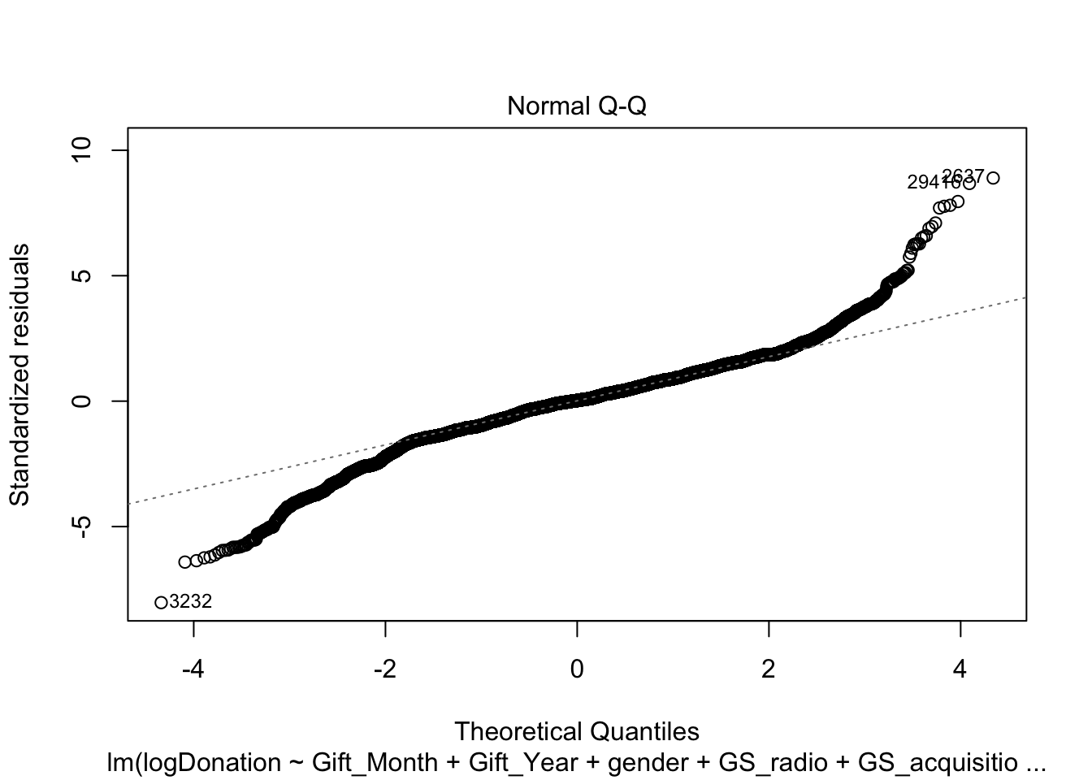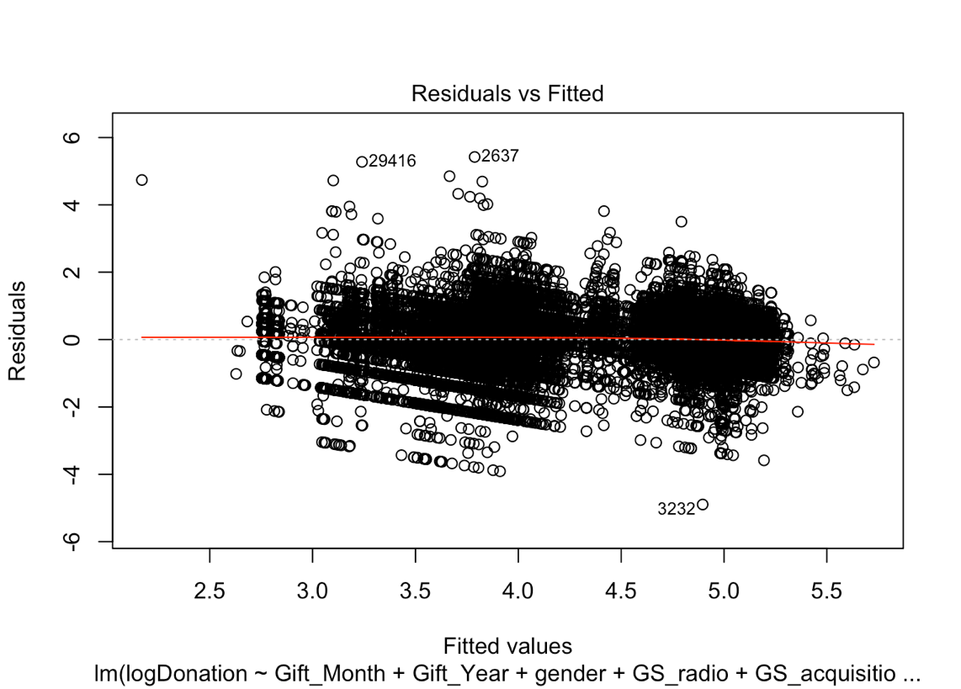

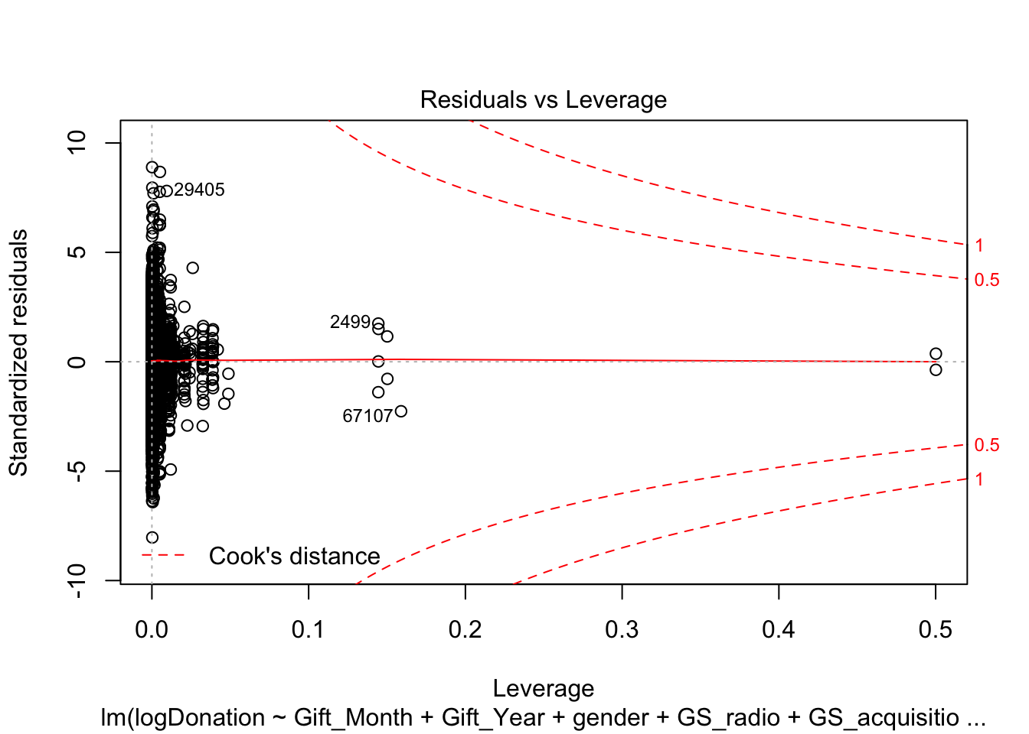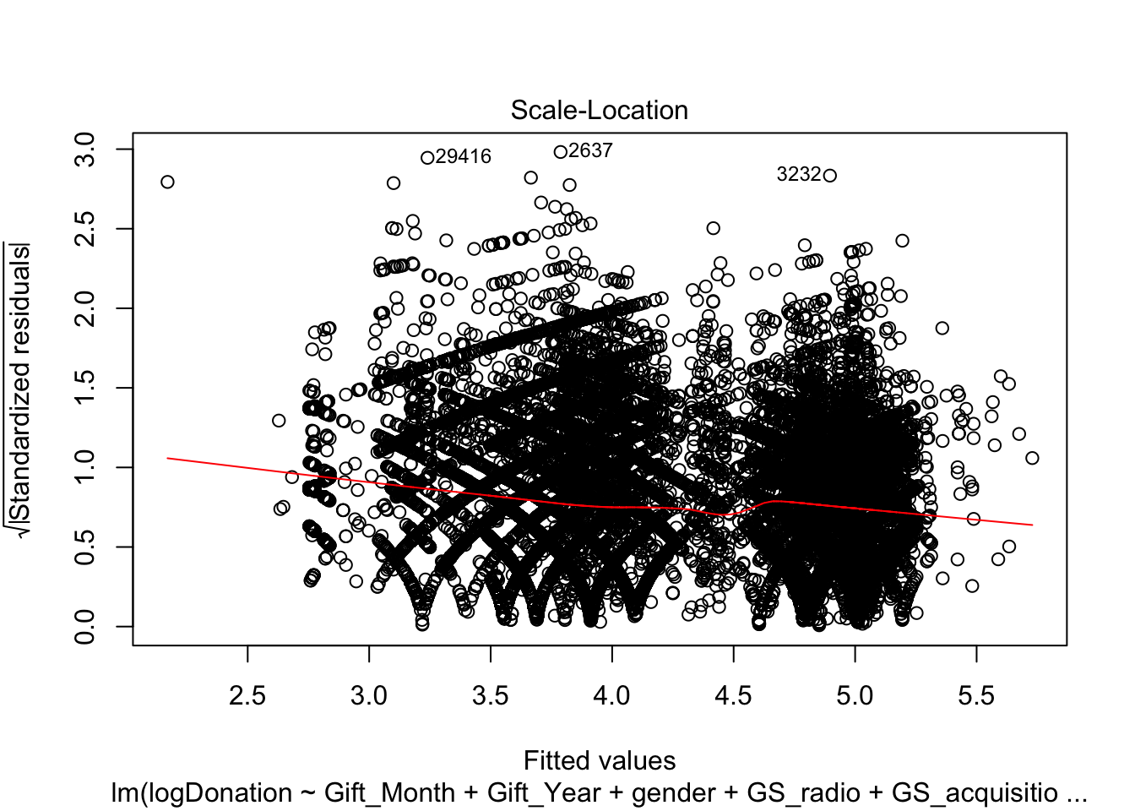

model_02x <- lm(logDonation ~ Gift_Month + Gift_Year + gender + GS_radio + GS_acquisition + GS_mail + GS_otwhite + GS_specialopportunity + GS_showcase + GS_passport + GS_annfund + GS_web + GS_mail + GS_cba + GS_oa + Orig_Gift_Has_Prm + Account_Status + Original_Gift_Mode + Region + Division , data = y_final_02)

summary(model_02x)

##

## Call:

## lm(formula = logDonation ~ Gift_Month + Gift_Year + gender +

## GS_radio + GS_acquisition + GS_mail + GS_otwhite + GS_specialopportunity +

## GS_showcase + GS_passport + GS_annfund + GS_web + GS_mail +

## GS_cba + GS_oa + Orig_Gift_Has_Prm + Account_Status + Original_Gift_Mode +

## Region + Division, data = y_final_02)

##

## Residuals:

## Min 1Q Median 3Q Max

## -4.9407 -0.3528 0.0147 0.3673 5.3554

##

## Coefficients:

## Estimate Std. Error t value

## (Intercept) -7.6532597 1.0728337 -7.134

## Gift_Month 0.0008196 0.0006596 1.243

## Gift_Year 0.0062828 0.0005339 11.767

## gendermale 0.0609452 0.0046927 12.987

## GS_radio -0.1891122 0.0058099 -32.550

## GS_acquisition -0.3343540 0.0121428 -27.535

## GS_mail -0.1760636 0.0295616 -5.956

## GS_otwhite -0.0926373 0.0204222 -4.536

## GS_specialopportunity 0.0180622 0.0159034 1.136

## GS_showcase 0.1240330 0.0351745 3.526

## GS_passport -0.0502266 0.0142747 -3.519

## GS_annfund -0.8326176 0.0442739 -18.806

## GS_web -0.1059161 0.0142524 -7.431

## GS_cba -0.3090147 0.0394436 -7.834

## GS_oa -0.7400077 0.0160999 -45.963

## Orig_Gift_Has_PrmN -0.9771796 0.0066979 -145.894

## Account_StatusActive 0.1408611 0.0063357 22.233

## Account_StatusContributor -0.4188914 0.0152926 -27.392

## Original_Gift_ModeOne time cash -0.1154920 0.0082632 -13.977

## Original_Gift_ModeMonthly Credit Card -0.0142820 0.0083721 -1.706

## Original_Gift_ModeEFT Monthly 0.0885633 0.0186883 4.739

## Original_Gift_ModeQuarterly Credit Card -0.1014617 0.0641772 -1.581

## Original_Gift_ModeEFT one time 0.0448810 0.1099116 0.408

## Original_Gift_ModeSemi Annual Credit Card -0.1623976 0.1199225 -1.354

## Region -0.0141584 0.0103206 -1.372

## Division 0.0133030 0.0033150 4.013

## Pr(>|t|)

## (Intercept) 9.87e-13 ***

## Gift_Month 0.214045

## Gift_Year < 2e-16 ***

## gendermale < 2e-16 ***

## GS_radio < 2e-16 ***

## GS_acquisition < 2e-16 ***

## GS_mail 2.60e-09 ***

## GS_otwhite 5.74e-06 ***

## GS_specialopportunity 0.256067

## GS_showcase 0.000422 ***

## GS_passport 0.000434 ***

## GS_annfund < 2e-16 ***

## GS_web 1.09e-13 ***

## GS_cba 4.78e-15 ***

## GS_oa < 2e-16 ***

## Orig_Gift_Has_PrmN < 2e-16 ***

## Account_StatusActive < 2e-16 ***

## Account_StatusContributor < 2e-16 ***

## Original_Gift_ModeOne time cash < 2e-16 ***

## Original_Gift_ModeMonthly Credit Card 0.088030 .

## Original_Gift_ModeEFT Monthly 2.15e-06 ***

## Original_Gift_ModeQuarterly Credit Card 0.113891

## Original_Gift_ModeEFT one time 0.683027

## Original_Gift_ModeSemi Annual Credit Card 0.175681

## Region 0.170114

## Division 6.00e-05 ***

## ---

## Signif. codes: 0 '***' 0.001 '**' 0.01 '*' 0.05 '.' 0.1 ' ' 1

##

## Residual standard error: 0.6111 on 69952 degrees of freedom

## Multiple R-squared: 0.4838, Adjusted R-squared: 0.4837

## F-statistic: 2623 on 25 and 69952 DF, p-value: < 2.2e-16

vif(model_02x)

## GVIF Df GVIF^(1/(2*Df))

## Gift_Month 1.031008 1 1.015386

## Gift_Year 1.656316 1 1.286979

## gender 1.007925 1 1.003955

## GS_radio 1.564695 1 1.250878

## GS_acquisition 2.390836 1 1.546233

## GS_mail 1.046139 1 1.022810

## GS_otwhite 1.125663 1 1.060973

## GS_specialopportunity 1.215166 1 1.102346

## GS_showcase 1.022379 1 1.011128

## GS_passport 1.458467 1 1.207670

## GS_annfund 1.051879 1 1.025612

## GS_web 1.188438 1 1.090155

## GS_cba 1.074893 1 1.036770

## GS_oa 1.629190 1 1.276397

## Orig_Gift_Has_Prm 1.970092 1 1.403600

## Account_Status 1.422845 2 1.092168

## Original_Gift_Mode 2.865592 6 1.091695

## Region 1.298819 1 1.139657

## Division 1.311109 1 1.145037

plot(model_02x)

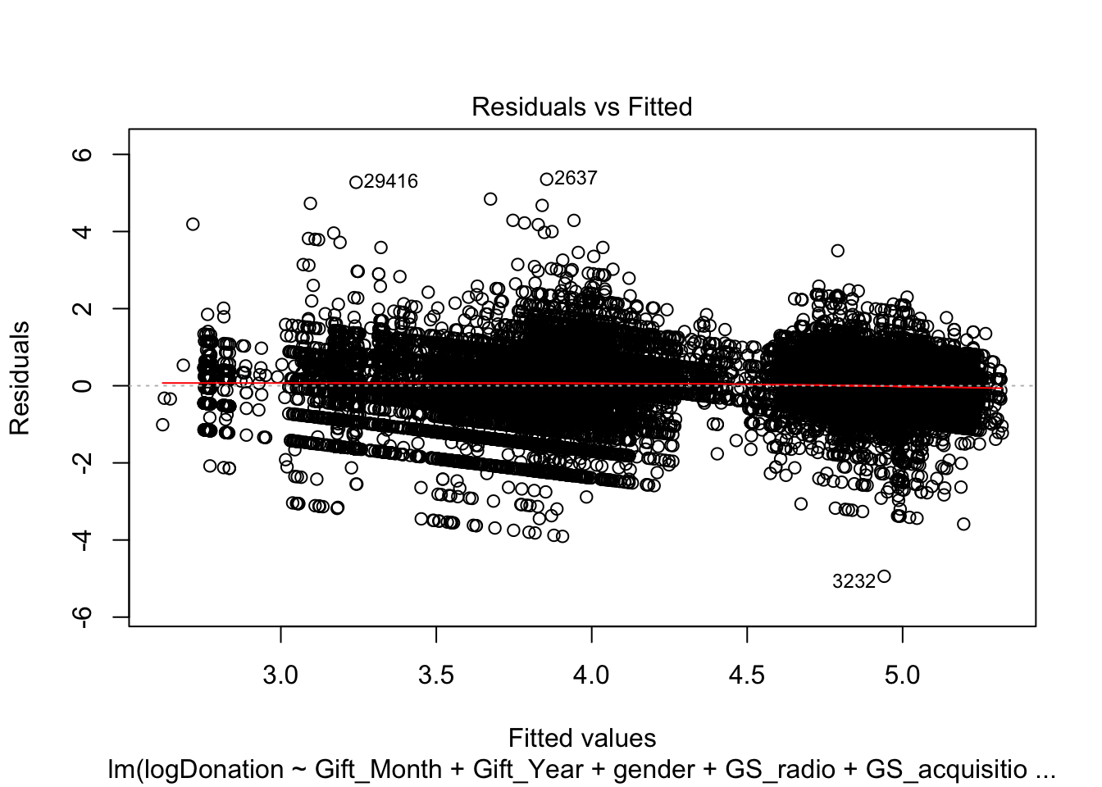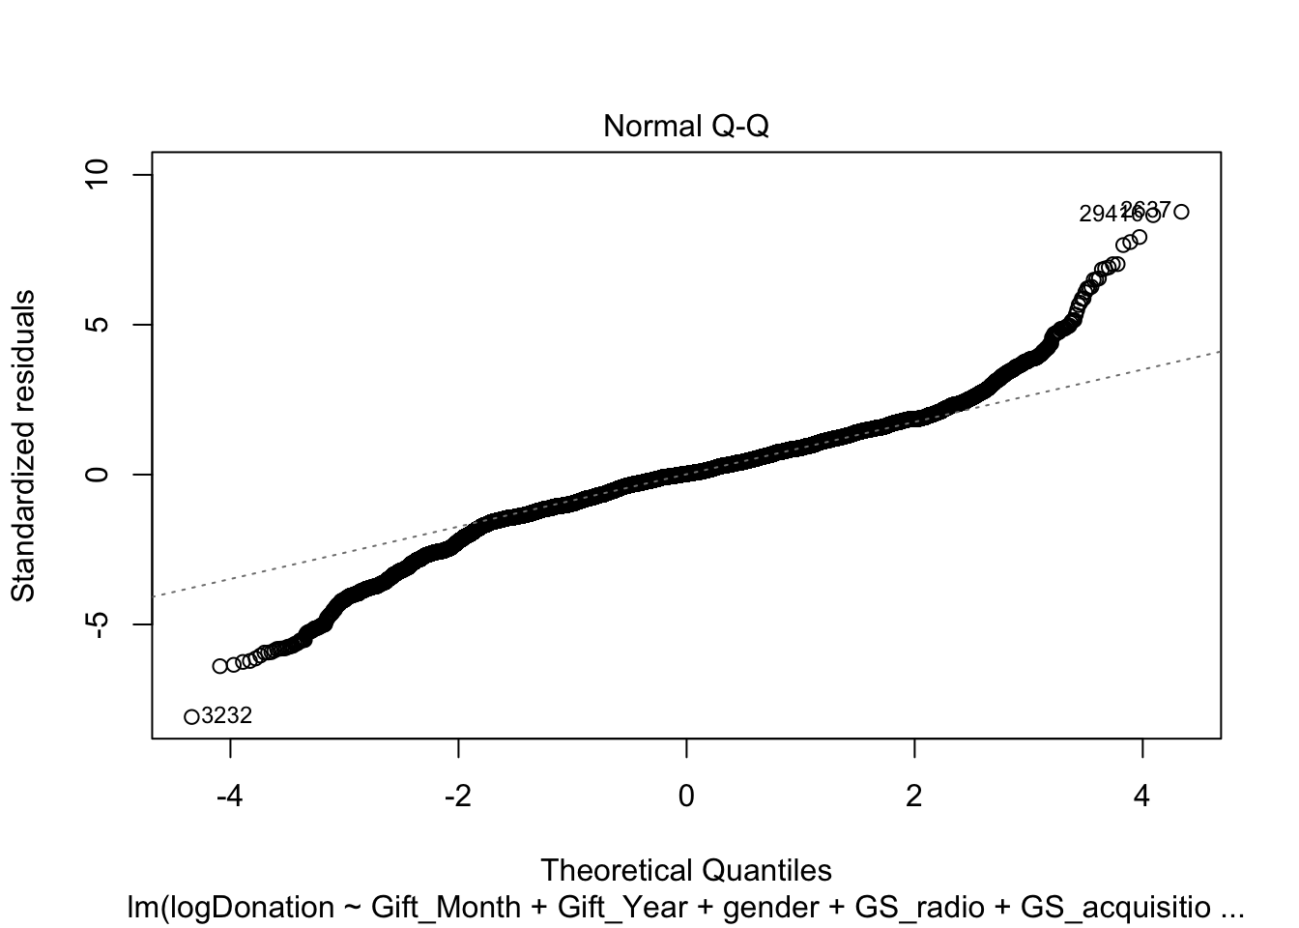





2 models are used for Predictive modelling. The dataset was split into 75% training set and 25% test set. Regression models were built with RMSE as the metric. The models were trained using Regression, Classification Tree, Random Forest, Gradient Boosting, Xtreme gradient boosting and Neural network.



**Figure 14**

The Models were then run with held out test samples as in the right-hand side chart of Figure 14. The box plot on the LHS shows the Root Mean Square Error which is the standard deviation of the residuals i.e. prediction errors.

Gradient Boosted Tree has the lowest RMSE and the best model that can be used for prediction. The R square of 53% is the statistical measure of proportion of variance of the donation that’s explained by the Original Gift Source and Solicitation Methods

**CONSIDERATION STAGES**



**Figure 15**

Here I am regressing the Mode of payment – EFT, Cash and Credit Cash versus various types of gift source.

The cells colored as yellow indicate the significance of the mode of payment used for the gift source.

Greyed out columns show Monthly Credit Card and Quarterly Credit Card are least significant

One-time Credit Cash is the most popular.



**Figure 16**

Here I am regressing the variable Original Gift has premium and the gender with Original Gift Source. Original Gift has premium means that when the donor made their first gift, they ask for a thank you gift. We see that statistically the thank you gift is not significant in boosting the donorship. Also, the donation from Male population is also less significant.

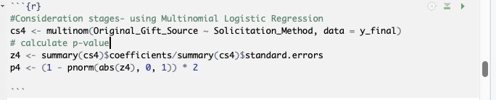

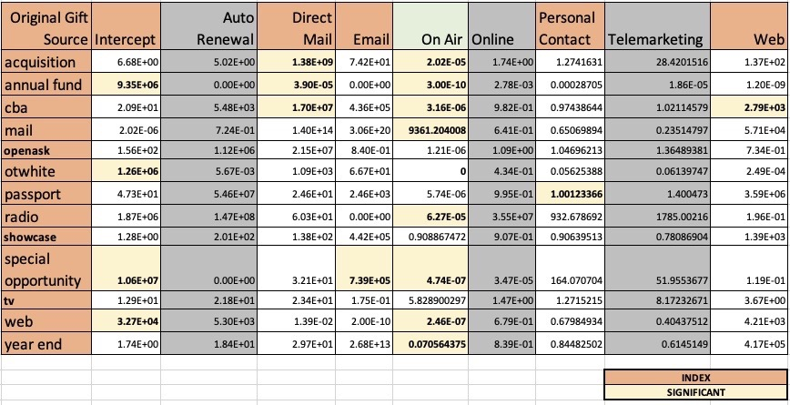

**Figure 17**

Here I am regressing the variable Solicitation Method like Auto Renewal, Direct Mail, Email, On Air, Online, Personal Contact, Telemarketing and Web to test for the significance on Original Gift Source. The greyed-out columns of Telemarketing, Online and Auto Renewal shows that they are not significant. The On-Air seems to be the most significant in the effectiveness of conversion with Gift source.

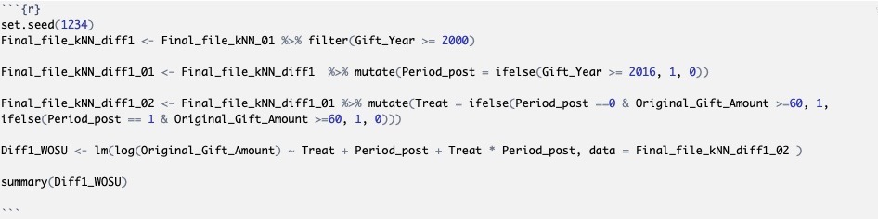

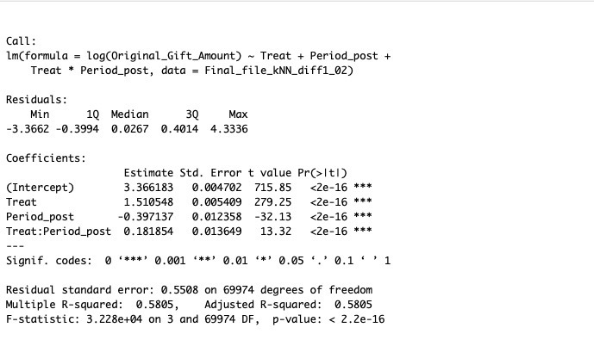

**Figure 18**

In the year 2016, WOSU started the Passport as a new member benefit with many privileges for donation of at least $60.00 or more.

So here I am trying to see the difference in outcome with the treatment as Passport being introduced.

And the regression has a lift of 0.18 which is differences in differences causal effect.

**PRESCRIPTIVE ANALYSIS**

*Prospects of Donor Expansion*

First time donations are a complement to the sustained and generous donations.

WOSU Public Media has always excelled in adding value and credibility and it does reflect in the lift in donor database analysis over the years.

With analysis of the base level data, I have identified opportunities to

- be used in campaign goals

- increase conversion and

- save costs.



**Figure 19**

Figure 19 shows that people prefer Credit Card as the most common mode of payment. This in turn can be interpreted as the fact that a convenient mode of payment can effectively increase the donation conversion. For the non-profit organizations, Text and pay is a very popular feature and can be advantageous to WOSU.



**Figure 20**

Zooming into the Solicitation methods as in Figure 20, it is clear that Passport and Web have a higher percentage of first-time donors retained among Active Donors. .



**Figure 21**

Original Gift has premium means that when the donor made their first gift, they ask for a thank you gift. Over the years we see an increasing trend of Donations without asking for gifts.

In the top right chart of Figure 21, we see the cost rate% for some gift sources (sum/total *100) are relatively high. And also, in the bottom charts, a greater number of donors have remained active after not choosing gifts, and more number of donors have expired who had accepted first time donation gifts.

So, it is good to give some consideration in keeping the option of “thank you” gift.

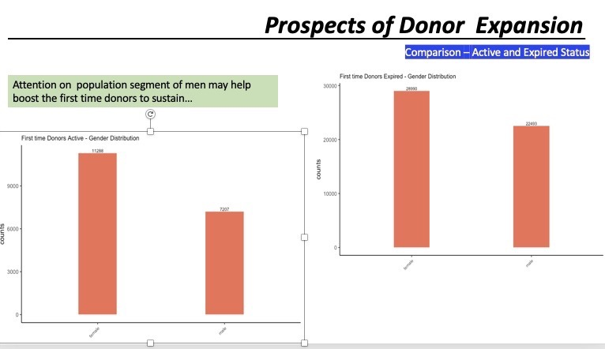

**Figure 22**

In the comparison of Active and expired status of donors in Figure 22, relatively Male donors have not sustained as compared to female donors , so a suggestion for consideration in the membership drive



**Figure 23**

In Event analysis in Figure 23, we observe that more non-donors (about 90%) are participating in the Events.

I see this as a good potential of subjects walking into these events

willingly and would be a good opportunity to solicit or can be encouraged to participate in a conjoint survey



**Figure 24**

Figure 24 is a sample of Conjoint Survey.

Conjoint survey helps in discovering the unmet needs or probe into the downstream effect of realization of donations.

The left chart shows the sample of conjoint survey with the Attributes and levels

and the right-hand side chart is a typical decision task.

Answers to these can help in adding more variables to know how people value different attributes and thus will be getting meaningful insights that may help in steering the membership drive.

**Conclusions**

It was overall a very interesting and insightful analysis where I was able to apply Data mining, Descriptive(networks, geo-visualizations, ggplots), Predictive and Prescriptive analysis and bring about a better understanding with insights into prospective Donor database expansion for WOSU Public media.

**Drawbacks**

The data analysis was done with databases having base line variables and attributes. The analysis would have been more insightful if we had additional survey data adding more variables to know how people value these attributes and thus can make Data analysis more organized and interpretative.

***Reference:***

Fundraising Analytics – Joshua M. Birkholz